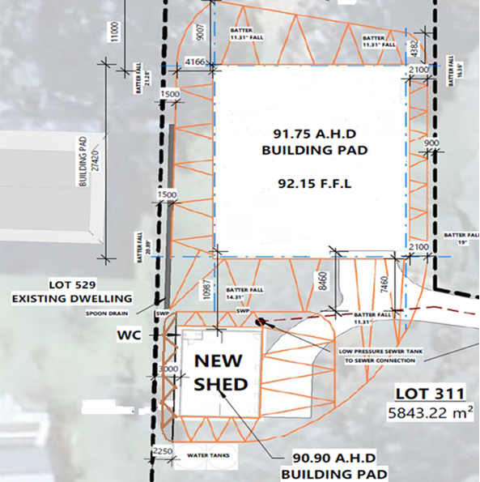

**House Pad from River (North)**

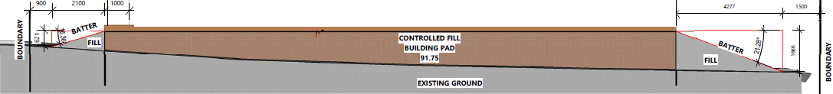

**House Pad from East**



**House Pad from South**



**House Pad from West (Including distance between house and Shed Pad)**

